Asset Allocation Strategies and Their Effect on Risk and Return from 1996 to 2000
JF Planning marzo 02
Recent volatility in the market has made investors much more aware of the potential risk in their investment portfolios. This article examines the effect that eight broadly defined investment categories would have on a portfolio over a five-year period. A wide range of investment strategies are used to determine the ideal mix. Surprisingly, given their sharp decline in 2000, technology stocks were the most profitable over the five-year period. Portfolios with a limited concentration of tech stocks would have resulted in a moderate level of risk and an above-average rate of return.
by Bruce Conrad, CPA, CFP, and Dann Salamie, MSIE, CPA
Bruce Conrad, CFP, CPA , is an associate professor at Marshall University in Huntington, West Virginia. He founded Diversified Investment Strategies, which manages investment portfolios, provides expert testimony and presents professional seminars.
Dann Salamie, CPA, MSIE, develops efficiency solutions for various industries, including pension fund management. His publication in a national medical journal has been developed into a series of professional seminars for CPAs and pharmacists.
For the last few years, most investors have concentrated on maximizing returns while paying little attention to their risk exposure. The 39 percent decline in the Nasdaq from early 2000 has been a painful reminder of the risks associated with investing.
With the large loss incurred by some investors in 2000, diversification, especially among different investment categories, has become a more popular way to realize competitive returns and limit downside risk. This article will examine different asset allocation strategies and their effect on risk and return over years 1996 to 2000. The following investment categories were used:
- Bonds:
Government Bonds
Corporate Bonds
High Yield Bonds
- Equity:
Large Cap Stocks
Small Cap Stocks
Foreign Stocks
Utility Stocks
Technology Stocks
The three bond categories (Government, Corporate and High Yield) and three of the equity categories (Large Cap, Small Cap and Foreign) represented the six major broad-based investment choices. Additionally, utility stocks were chosen as a separate investment category to measure the effect of a lower-risk equity on a portfolio. Technology stocks were included as a separate category to measure the effect of a highly volatile equity group on a portfolio.
For each of the eight categories, ten mutual funds were randomly selected based on the following criteria:
- Initial minimum investment of less than $10,000
- Funds were required to be 80 percent or more invested in the designated investment category
- Funds were required to be in existence for at least five years
- Ranking of 3 to 5 by Morningstar
Morningstar was chosen as the database because of its national recognition as a premier source of information regarding mutual funds. Morningstar offers several databases. The specific one chosen for this study was the hard copy form that is distributed to a large number of libraries across the country. That source covers approximately 1,500 mutual funds listed by investment categories. For the majority of the categories, there was a large sample of funds from which to choose. There were three categories (High Yield Bonds, Utility Stocks and Technology Stocks) in which the number of funds that met the criteria was rather small. Any meaningful change in the criteria would have significantly affected the pool of funds from which the sample was selected.
The funds selected for the study represent a wide cross section of the mutual fund industry. Forty-six different mutual fund families are represented. Thirty-eight of the funds are no-load and 42 funds are load.
Rates of return were based on dividends paid and appreciation of market value for each year from 1996 to 2000. Because this study emphasized the effect of diversification and the interaction of various investment categories, there was no adjustment for front- or back-end loads in the returns. To ensure that the overall returns were reflective of that investment category, the returns for each year were averaged together before any calculation or analysis was performed.
Time Period Selection
One challenge presented by the study concerned the selection of an appropriate time period. It had to be long enough to show how the various asset allocation strategies would react in a variety of market conditions, yet short enough to reflect the market environment over the last few years. The use of time periods of ten years or more would have eliminated a substantial number of the more recently established mutual funds and, in some asset categories, would have presented too small a pool of funds from which to choose. For example, Morningstar reviews 40 mutual funds in the Technology category. Twenty-one of those funds meet the five-year criteria but only 12 would have met the ten-year criteria. Consequently, a five-year time period was selected because it would allow sufficient time to measure the response of the asset allocation to various economic events, and it would provide an adequate pool of mutual funds from which to choose.
To test the validity of the study results, the most volatile bond and equity categories were examined. Every high yield bond and technology fund with at least a five-year track record was reviewed. The five-year total returns for each category were calculated and compared with the sample. In both cases, the return of the sample and the return of all the funds were within less than one percent per year on an annualized basis. Any difference that does exist is too small to significantly affect the results of the study.
When determining which combination of investments is the most appropriate for a given investor, total return is not the sole criterion. Every investor is affected, to some degree, by the year-to-year volatility of their portfolio. Some investors have relatively low tolerance for short-term losses while others can accept substantial declines in the short run and focus on long-term returns. It is not unusual for investors to become more risk averse and seek a higher level of safety as they near retirement. This article will attempt to help investors clarify their options by emphasizing the trade-off between risk and return. The final determinant of the most appropriate portfolio will hinge on an investor’s risk tolerance and the amount of volatility he or she is willing to accept.
Table 1 lists the average beta, actual average five-year return and the return an investor should have expected based on the beta of the portfolio for the eight investment categories. As expected, the five equity categories substantially outperformed the three bond categories. All five equity categories outperformed the Dow Jones Industrial Average and the S&P 500 index. Even though they posted large declines in 2000, technology stocks had the best five-year compounded return: 245 percent. Although government bonds had a positive return for each of the five years, their five-year return was a fraction of the return for technology stocks. The returns from 1996 through 2000 illustrate the classic dilemma investors face between risk and return.
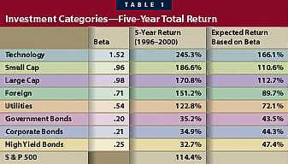
Beta has been one of the primary indicators when determining an investment’s volatility. The betas used were calculated by Morningstar and are available for all the funds reviewed in that publication. In general, the betas were in line with expectations. Over the last five years, technology stocks have been the most volatile sector in the equity market and they correspondingly had the highest beta (1.52). Utility stocks, which are considered a lower risk alternative in the equity market, had the lowest equity beta (.54). In this study, utility stocks were able to generate a positive return in each of the five years. The three bond asset categories that were much less volatile and posted lower actual returns all had substantially lower betas. Consequently, their lower overall returns were mostly a function of their lower risk.
The "expected returns based on beta" were calculated to determine if investors were being properly compensated for the level of risk they were absorbing. By comparing the actual return with the expected return, one can determine if the investment category performed better than expected after considering its overall volatility. The expected returns were based on the betas of the investment categories and the return in the overall market each year (K_{RF} + B (K_{M} – K_{RF})). Each year’s expected return was multiplied by the previous year’s expected return, resulting in a five-year compounded return for each investment category. A similar calculation was performed for each of the investment portfolios.
Returns Above Expectation
Each of the five equity investment categories outperformed their respective expected returns by a substantial margin. Though utility stocks had the lowest return in the equity sector, their actual five-year returns, when adjusted for their lower risk (beta), were almost double the expected return. Foreign and small-cap stocks performed second best, almost 70 percent better than expected followed by the technology and large-cap stocks that did 50 percent better than expected. Based on these comparisons, over the last five years, investors have been more than adequately compensated for assuming additional risk, even considering the substantial losses some experienced in 2000.
Unfortunately, each of the three bond categories had substantially lower returns than the five equity categories. Considering the three bonds’ expected return, it is clear that most of the lower returns are due to the lower risk associated with the three bond categories. Only a small portion of the difference between equity and bond returns was due to poor performance after factoring out risk.
To indicate the year-to-year volatility of the eight investment categories, Table 2 shows the annual returns. The investment categories are ranked from the highest to the lowest return. Only three of the eight categories had positive returns every year, shown in Table 3.
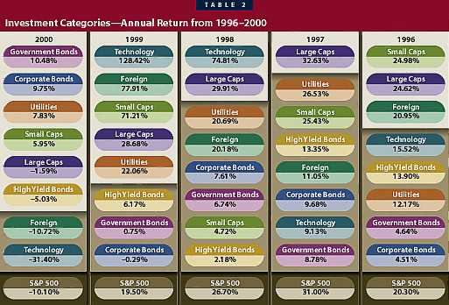
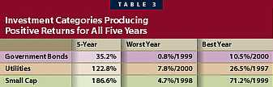
Technology stocks were the most inconsistent of the eight categories. They were the best performers in 1999 and 1998 and the worst, or second worst, in 2000 and 1997. The bond categories were relatively consistent performers, managing only minor losses in the down years and moderate gains in the good years.
Even though for many investors the year 2000 will be remembered as a very bad period, half of the investment categories examined made a profit in 2000. Additionally, only two categories lost more than 10 percent (Foreign Stocks –10.7 percent and Technology –31.4 percent).
For most investors, the volatile nature of any one investment category would be unacceptable. The purpose of this article is to illustrate how various combinations of investment categories affect the year-to-year volatility of a portfolio and its overall five-year return.
The first two portfolios that were created emphasize the two extremes. The first portfolio is all bonds and the second, all stocks (see Table 4). For most investors, neither extreme is appropriate but the contrast will demonstrate the clearest example of risk versus return. The all-bond portfolio used the three bond categories and the all-stock portfolios used the five equity categories. All the categories were weighted equally.
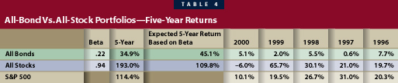
The all-stock portfolio was able to outperform the S&P 500 over the five years mainly due to the superior performance of the technology, foreign and small-cap segments in 1999. If those three categories are discounted for 1999, the five-year overall return for the all-stock portfolio would have been 121 percent compared with the S&P 500 return of 114 percent.
More important than the individual rates of return is the comparison of risk and return between the two portfolios. The all-stock portfolio did have one year of losses while the bond portfolio posted a profit every year. However, the loss in the stock portfolio was only –6 percent, which most investors could probably withstand in light of earning a profit over the entire five years that was almost six times higher than that of the bond portfolio.
If the actual returns are compared with the expected returns that factor in risk, the all-stock portfolio not only posted the highest overall return but also outperformed the expected return by a substantial margin. The much lower five-year return for the all-bond portfolio was due mostly to the lower-risk nature of its investments. Comparing the all-bond portfolio’s actual five-year return with its expected return, it is clear that some of the underperformance was also due to the investment not earning what it should have after considering its inherent risk.
Blended Portfolios
For the vast majority of investors, the much lower return on bonds is too big a sacrifice. The next set of asset allocations attempts to incorporate the stability of a bond portfolio with the higher returns of the equity portfolio. Four combinations were calculated; results of the four strategies are shown in Table 5.
- 5 percent for each of the three bond categories and 17 percent for each of the five equity categories
- 10 percent for each of the three bond categories and 14 percent for each of the five equity categories
- 15 percent for each of the three bond categories and 11 percent for each of the five equity categories
- 20 percent for each of the three bond categories and 8 percent for each of the five equity categories
As more bonds were introduced into the portfolio, the five-year returns decreased. That would be expected as the portfolios became less volatile and had a lower beta. All four portfolios outperformed their expected returns but the magnitude of that difference declined dramatically as more bonds were introduced.
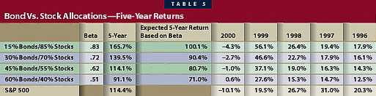
Two out of the four allocations had a larger five-year compounded rate of return than the S&P 500 while incurring a much smaller loss in 2000. Once again, the price an investor had to pay to avoid a loss in 2000 was very high. Only an investment in the most conservative of the four strategies would have yielded positive results in 2000. Such an action would have almost cut in half the five-year return compared with the five percent allocation in bonds.
Although no investor likes to lose money, allocating the smallest amount in bonds (5% x 3 = 15%) provides the following: (1) a five-year return substantially above the return of the S&P 500 (165.7 percent versus 114.4 percent) and (2) a loss in 2000 of less than five percent.
The portfolios in Table 6 were created to discover the effect on risk and return of concentrating a substantial portion in one category (65 percent) with minimal amounts (5 percent each) in the other seven categories. Concentrating 65 percent of the portfolio in one asset category would be appropriate only for the very risk averse (those portfolios concentrating on bonds) or those willing to assume substantial risk (those preferring a substantial stock concentration). For the average investor, any of the concentrated portfolios probably would not provide sufficient diversification.
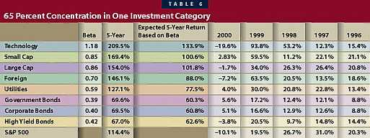
Concentrating 65 percent in a single area while investing five percent in each of the other seven categories produced the following results:
- As we have seen repeatedly, large concentrations in equity mutual funds resulted in substantially higher returns and more volatility
- All eight portfolios outperformed their corresponding expected return. Those portfolios that concentrated on equities outperformed their expected returns by substantially more than the bond portfolios.
- All five equity investment concentrations generated higher five-year returns than the S&P 500. In all cases except technology, the allocation produced smaller losses than the S&P 500.
- All three bond concentrations were virtually interchangeable with regard to five-year actual returns, betas and expected returns.
- Minimal diversification still resulted in a substantial loss (–19.6 percent) in 2000 for the technology stocks. Even with a major loss in 2000, technology stocks were still the best-performing concentration.
- With the exception of the technology area, the losses sustained in 2000 were relatively moderate (–1.7 percent to –7.2 percent). For a moderately risk-averse investor, the four equity concentrations (Small Cap, Large Cap, Foreign and Utilities) generated acceptable returns with minimal levels of risk.
- The small-cap stock concentration provided the best of both worlds—the second highest return and no losses in 2000.
- For very risk-averse investors, the utility stock concentration would have provided a good compromise. The overall five-year return was as good as the S&P 500 and the level of volatility approached bond concentrations.
The eight portfolios in Table 7 allocated 10 percent to each of the seven investment categories and the remaining 30 percent to a particular investment. This was done to determine how a broader diversification strategy with a single overweight concentration affected risk and return.
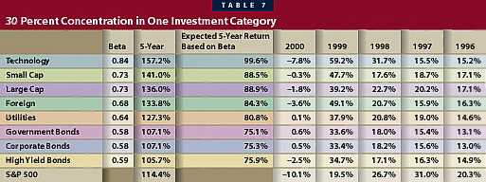
Concentrating 30 percent in one area while investing 10 percent in each of the other seven investment categories produced the following results:
- As would be expected, the effect of lowering the concentration from 70 percent to 30 percent moderated the extremes. The overall five-year return of the technology stocks was reduced from 209.5 percent to 157.2 percent, while the 2000 loss declined from –19.6 percent to –7.8 percent. On the other extreme, the five-year performance of government, corporate and high yield bonds portfolios increased by approximately 50 percent.
- All five equity concentrations outperformed the S&P 500 index over the five years. In addition, four of those concentrations posted a smaller loss than the S&P 500 in 2000, thus generating higher overall returns with less downside risk than the S&P 500.
- Even the bond concentrations yielded relatively similar returns compared with the S&P 500 with much less downside risk.
- Reducing the technology concentration from 70 to 30 percent reduced the loss in 2000 from 19.6 percent to a much more tolerable loss of 7.8 percent. Unfortunately, this came with a substantial reduction in the five-year return (209.5 percent to 157.2 percent).
- By reducing the overweighting of one investment category to 30 percent, the betas for the eight portfolios became much less extreme (.84 versus .58 compared with 1.18 versus .39). Five of the portfolios had betas within .10 of one another (Foreign stocks, Utilities, Government Bonds, Corporate Bonds, High Yield Bonds).
- All eight portfolios outperformed their respective expected returns. The three all-bond portfolios substantially outperformed their expected returns compared with the portfolios with 65 percent concentration. The lowering of the concentration from 65 to 30 percent moderated the risk and the returns sufficiently to be attractive alternatives for the majority of moderate risk investors. At a 65 percent concentration, the three all-bond portfolios substantially limited actual returns to reduce overall risk. However, the 30 percent concentration generated high enough returns to attract risk-averse investors.
After experiencing large losses in the technology stocks in 2000, most investors are hesitant of this market sector. The three portfolios in Table 8 were created to illustrate the effect of a very aggressive asset allocation with a heavy concentration of technology stocks. These portfolios would be appropriate only for very risk-oriented investors.
- 80 percent technology and 5 percent in each of the other equity categories
- 60 percent technology and 10 percent in each of the other equity categories
- 40 percent technology and 15 percent in each of the other equity categories
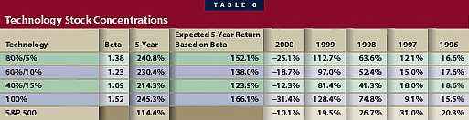
The concentration in technology stocks balanced by the four other equity categories produced these results:
- The 80 percent and 60 percent allocations to technology stocks did produce very attractive five-year returns but, unfortunately, still resulted in major losses for 2000. Most risk-averse investors would have difficulty coping with the substantial potential loss.
- The 40 percent allocation resulted in almost twice the return as the S&P 500 (214.3 percent versus 114.4), while the worst loss was approximately the same (–12.3 percent versus –10.1 percent). The investor willing to take on the additional risk would have been more than amply rewarded.
- Every one of the portfolios substantially exceeded the expected five-year return. Those investors prepared to assume an occasional substantial loss were more than well-compensated for their efforts.
Not Tomorrow’s Blueprint
What has occurred over the last five years is not a blueprint of what will occur in the next five years. The one thing investors can be sure of is the occurrence of unanticipated economic events causing the bond and stock markets to react in unpredictable ways. If duplicated, the asset allocation discussed in this article would not result in the same returns over the next five years. The relevance of this study lies in illustrating the effect of various asset allocations on risk and return. The findings can be summarized as follows:
- The type of diversification between investment categories does make a substantial difference in overall long-term returns and year-to-year volatility.
- Any significant allocation to bonds does reduce the year-to-year volatility, but at the same time significantly reduces the long-term return. For most investors, any major allocation to bonds will begin to lower returns to such a point that they will begin to consider if the reduction in risk is worth the price.
- The limited use of bonds (15 percent to 30 percent) can be an attractive asset allocation for investors willing to sacrifice some returns for lowered volatility.
- Protection from even minor losses would necessitate a diversification strategy that would sacrifice a substantial portion of potential long-term gains.
- Over the last five years, investors who purchased equity were well-compensated, even considering the additional risk absorbed as indicated by the substantial gap between actual and expected returns.
- Technology stocks in moderation (30 percent) in a widely diversified portfolio can result in a portfolio with controlled volatility (beta equals .84) and above-average performance (157.2 percent).
In the final analysis, the best asset allocation for an investor will be determined by how much volatility he or she is willing to absorb from one year to the next. What one investor thinks is acceptable, another will see as too conservative or aggressive.

