Broker/Dealer Special Report
How Independent Advisors Select Independent Products
JFP April 2006
What matters most to independent advisors when choosing products within a particular category for their clients' portfolios? Certainly you could call around and ask colleagues in your community or those located across the country who you've met at professional conferences. It's unlikely, however, that you would devote the time to check in with 821 practitioners to find the answers.
That's exactly what Boston-based Financial Research Corporation did on behalf of the Financial Planning Association. The final results of that survey are still being compiled, but what follows is a small excerpt lifted from the soon-to-be-released research. Details for purchasing the complete study can be found on page 82.—Ed.
A. Product Selection Screens
Let's zoom in to take a close look at the various screens independent advisors use when determining which products within a particular product category will be included in their clients' portfolios. We will examine not only the specific selection screens that are used, but will also study the frequency with which those screens are applied.
As Figure 1 clearly shows, a product's expense ratio is the most widely used selection screen by our sample, with 620 respondents indicating they use this screen to narrow down their investment choices. Moreover, when asked to specify the frequency with which a product's expense ratio is used as a screen, 69% of this group (428 out of 620) said they always consider expense ratio—a greater frequency than for any other selection screen.
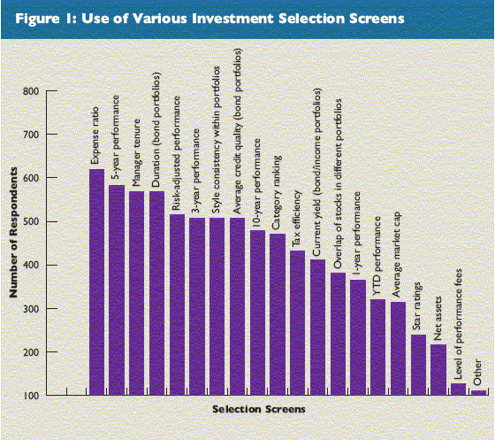
Rounding out the top 10 selection screens, after expense ratio, the following are the most frequently used screens by our advisor sample, listed in rank order:
- Five-year performance
- Manager tenure
- Duration (for bond portfolios)
- Risk-adjusted performance
- Three-year performance
- Style consistency within portfolios
- Average credit quality (bond portfolios)
- 10-year performance
- Category ranking (as in a fund's rank within its Lipper or Morningstar peer group)
Expense Ratio
Turning back to expense ratio, the fact that it is the screen used most frequently by the greatest number of respondents is surprising against the backdrop of findings from the group of mostly independent advisors surveyed in 2003. For that group, the question of selection screens was focused strictly on mutual funds whereas the current survey takes a broader approach. Nevertheless, since both samples use mutual funds extensively, we think the comparison is directionally valid if mutual funds are accepted as a reasonable proxy for comparative purposes.
While the group in 2003 considered a mutual fund's expense ratio to be an important selection screen, it was not the most important screen nor was it the most frequently used screen. In fact, when viewed according to the percentage of respondents who indicated that they use a particular screen always or frequently, expense ratio ranked seventh, behind risk-adjusted performance and just ahead of three-year performance (see Figure 2).
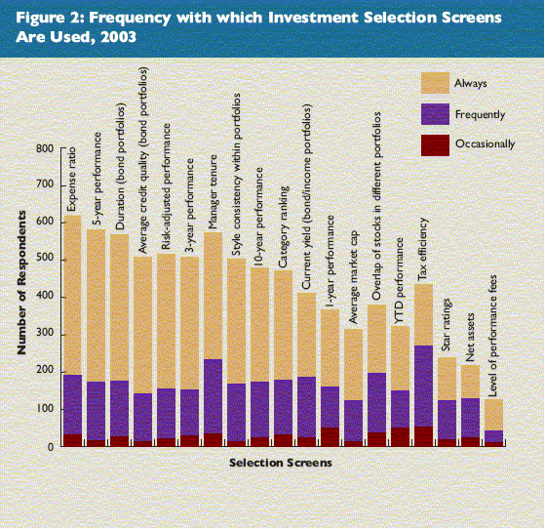
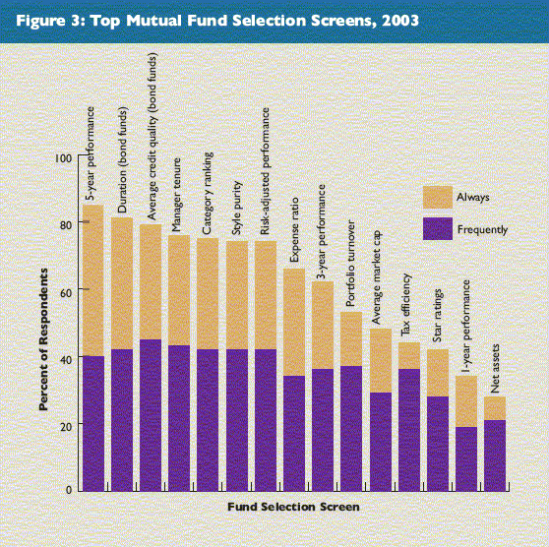
What factors have caused independent advisors to increase their emphasis on expense ratio as a product selection screen? One answer is that, in the wake of the Spitzer investigations and subsequent settlements, the issue of fees embedded in the structure of not only mutual funds but other products as well, is at the front of advisors' minds because their clients are asking about it. While the settlements involved only a handful of fund firms, the regulatory climate has changed and firms are now required to provide much greater transparency and justification for the various components that make up a product's total fee. Many asset managers that were not required to cut their fees cut them anyway to avoid being spotlighted as having higher-than-average product costs. Thus, as advisors watch certain industry leaders reduce their fees the whole issue of fee competitiveness is brought into stark relief.
Another reason for the focus on expense ratios is the influence of industry watchdogs like Morningstar. A study conducted by Morningstar in mid-2005 concluded that expenses are a more accurate predictor of fund performance than historical returns.¹ In fact, the firm wrote that an investor who randomly picks a fund in the bottom quartile of both expenses and five-year returns will likely do better than an investor who selects a fund in the top quartile of expenses and five-year returns. In addition, Morningstar regularly comments on the importance of screening for funds that combine management continuity with solid track records that are available at below-average cost relative to peers.
Competitive pressure from ETFs and reduced-cost index funds is another reason independent advisors have intensified their focus on expense ratios. According to Morningstar, the median expense ratio is 0.3% for ETFs and 0.35% for no-load index funds, compared to 0.96% for all funds and, according to Lipper, 1.45% for actively managed, diversified U.S. equity funds. What's more, Fidelity and Vanguard spent significant parts of 2004 and 2005 engaged in a price war involving their index funds, matching fee cut for fee cut in order to hold the title of lowest-cost index provider.
Finally, a small but growing number of advisors are lowering their fees in the hopes of improving their competitive position vis-à-vis other advisors. There is anecdotal evidence to suggest that more advisors are charging fees of 0.25% to 0.5% for their services, which is substantially below the traditional 1% asset-based fee levied by many advisors.² In order to demonstrate their competitive advantage to clients, advisors that are charging lower total fees are migrating to low-cost products to minimize the embedded management expenses that clients must bear. As a result, these advisors are using ETFs and passively managed products almost exclusively.
Fixed-Income Screens
The two most frequently used screens for selecting fixed-income products are average credit quality and duration. Average credit quality is an aggregate measure of the default risk, and thus, principal safety, of the bonds within a given portfolio. Duration is a measure of a portfolio's sensitivity to changes in prevailing interest rates. These two indicators are used about equally by independent RIAs. IBD advisors, on the other hand, tend to focus somewhat more on average credit quality.
B. Other Selection Screens
The ranking of most of the other product selection screens were relatively consistent with what we've observed in prior research. Screens such as five-year performance, manager tenure, risk-adjusted performance, style consistency, and duration and average credit quality (for fixed-income portfolios) are used most frequently by the greatest number of advisors. At the same time, screens such as net assets, star ratings, one-year performance and average market capitalization are used less frequently by a smaller number of advisors.
As for selection screens that were not listed but were written in, 112 respondents said they use one or more of the following screens frequently:
- Standard deviation, alpha, beta, R-squared and Sharpe ratio
- Correlation to a benchmark and to the overall market
- Rolling returns and consistency of returns
- Portfolio turnover
- Performance rank during bear markets
- Largest upside and downside returns within a 12-month period
- Extent to which a manager has invested in the portfolio him/herself
- Low tracking error (index funds)
- Sensitivity to social and environmental issues
- Manager's ability to articulate their approach
Endnotes
- As cited in "Fund Fees: Up or Down?" Barron's, August 15, 2005
- "Advisers lower fees to capture assets," Investment News, January 16, 2006
This article is excerpted from a newly released FPA/Financial Research Corporation (FRC) joint study titled "Effectively Servicing and Supporting the Independent Financial Advisor." The findings of this co-branded study are based on an extensive, Web-based survey of 821 geographically dispersed advisory firms, all of whom are members of the Financial Planning Association. For additional information about this study, please contact FRC at 888.491.9788 or at frcinfo@frcnet.com.

